Publishing at UNCW

To publish your site within Visual Studio, first save all of your individual pages, then select:
Build –> Publish Web App
In the window that appears, enter the following information
- Choose custom and name it “UNCW”
- Publish Method: ftp
- Server: ftp://student.uncw.edu
- Site Name: <leave blank>
- User name: <your uncw-email ID>
- Password: <your uncw-email password>
- Click on “Publish”

****Note: abc1234 should be your UNCW id (do not include @uncw.edu)****
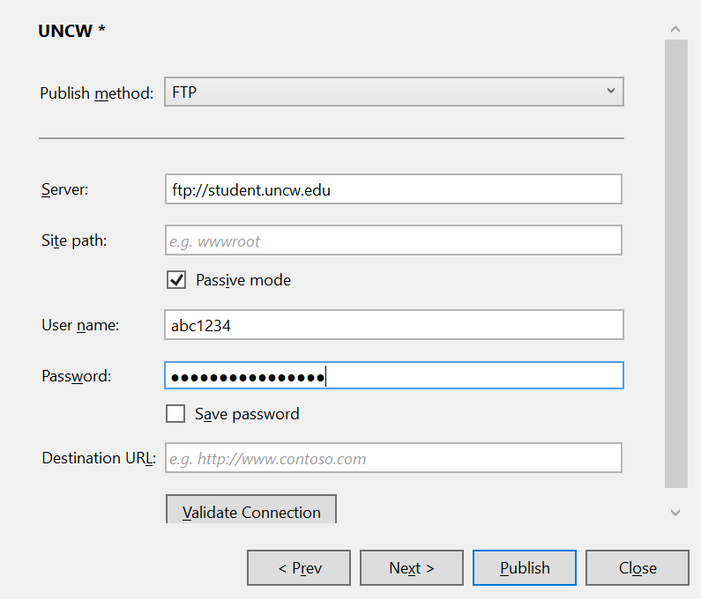

Open a browser at: http://student.uncw.edu/abc1234
***abc1234 should be your email id.
Check the result of your upload: Note that you just uploaded HTML-code to the UNCW web-server that can then be accessed
More information on publishing your site to the UNCW webserver can be found here:
http://uncw.edu/web/websitespersonal.html

